Sponsorship Form
Please tick here and complete ALL the sections of the form. We can only claim money back if all sections are complete. Don’t forget to confirm that you agree with the declaration below.

I’m hoping to raise £……………………………… My event is: ……………………………………………..

Name: ………………………………………………………………………………………………………....…...

Email address: ……………………………………………..……Postcode: ……………………………….….
Please return your sponsorship form and donations to:
Edo Development Aid
Finance Department
32 Park Lane
Wembley
HA9 7RZ

Title | Initial | Surname | House number/name (home, not work) | Postcode | Amount |  | Date Collected
Mrs | C | Jones | 53 | KT17 2HU | £30 |  | 01 July 2020
Sub Total: |  |  |  |  |  | Please make Cheques payable to:  ‘Edo Development Aid’

Title | Initial | Surname | House number/name (home, not work) | Postcode | Amount |  | Date Collected
Mrs | C | Jones | 53 | KT17 2HU | £30 |  | 01 July 2021
Sub Total: |  |  |  |  |  | Please make Cheques payable to:  ‘Edo Development Aid’
Participant’s Signature: ……………………………………………..……

Date of Declaration: ………………………………………………………

Date submitted to charity: ……………………………………………….

Gift Aid declaration: If I have ticked the box headed ‘Gift Aid’, I confirm that I am a UK Income or Capital Gains taxpayer. I have read this statement and want the charity or Community Amateur Sports Club (CASC) named above to reclaim tax on the donation detailed below, given on the date shown. I understand that if I pay less Income Tax/or Capital Gains tax in the current tax year than the amount of Gift Aid claimed on all of my donations it is my responsibility to pay any difference. I understand the charity will reclaim 25p of tax on every £1 that I have given.
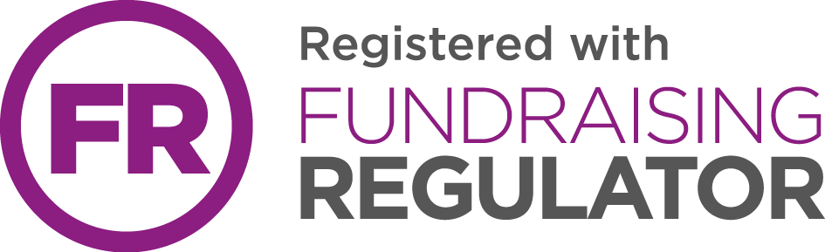
Edo Dev Aid is a dual registered charity in England and Wales, with the Charity Commission, Charity number 1188371 and with Companies House, Registration number 11884855

